CS-340 README

Grazioso Salvare Animal Rescue Dashboard

Brian Reith

CS340 Client/Server Development

Professor Jeff Sanford

About the project
Project Title: Grazioso Salvare Animal Rescue Dashboard
This project delivers a comprehensive full-stack web dashboard designed to interface with a MongoDB database containing animal shelter data from Austin, Texas. Its primary objective is to efficiently identify and categorize dogs that exhibit strong potential for search and rescue training. The dashboard enables Grazioso Salvare personnel to filter animals by rescue type, examine results within an interactive data table, and access visualizations such as a breed distribution pie chart and a geolocation map for enhanced data interpretation.

Motivation
Grazioso Salvare collaborates with five animal shelters in the Austin, TX area and needs a streamlined tool to efficiently search shelter records for suitable rescue dog candidates. Without this application, staff would have to manually query the database or sift through raw data. The dashboard saves time on record searches, reduces user errors, and offers visual data summaries that support quicker and more informed decisions about which animals to select for training programs.

Getting Started
To execute this project, you must have access to the Codio Environment with MongoDB properly installed and operational. Additionally, Python and Jupyter Notebook should be available.

Installation

Step 1 – Install Required Python Libraries
PIP install Pymongo jupyter-dash dash dash – leaflet plotly pandas numpy

Step 2 – Import AAC Dataset into MongoDB
Import the Austin Animal Center Outcomes CSV File ingo MongoDB using

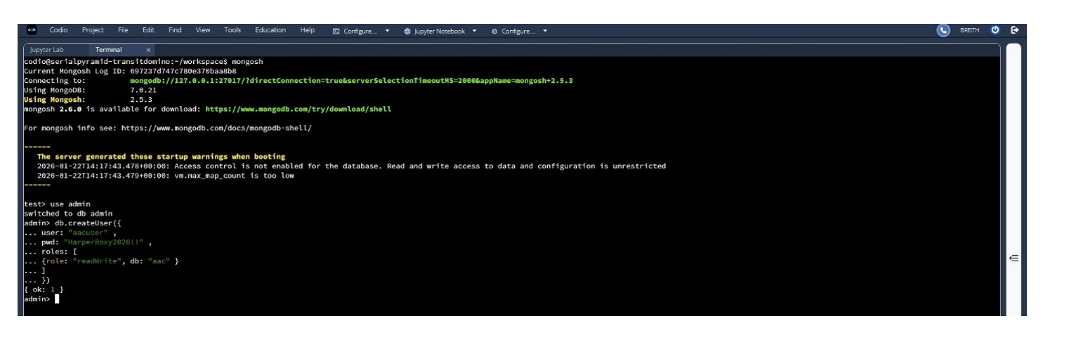

5. About the project
Access to the relevant MongoDB database is essential. MongoDB was selected as the model component for development due to its versatility and flexibility. It efficiently handles multiple objects and excels at managing real-time data. The Dash framework supplies both the view and controller structures for the web application, enabling users to interact seamlessly with all features through an intuitive interface. To ensure proper connectivity, it is important to install the pymongo library by executing `pip install pymongo` in your environment. Among the operators utilized is the `update_many` command, which searches for specified documents; if found, the documents are updated accordingly, otherwise, a notification indicates that no such document exists. Dash Framework was selected because it allows for building interactive web dashboards entirely in python. We also used Dash leaflet for a geolocation map that was used to display animal shelter locations on a map centered in Austin TX. Lastly, we used Plotly expressed to generate the breed distribution pie chart. This updates automatically when the data is filtered.

6. USAGE
Once the dashboard is running users interact with it through the following components:
- Radio Buttons – Select a rescue type filter. Water Rescue, Mountain/Wilderness, disaster/ individual tracking or reset which is unfiltered.
- Data Table – Displays filtered shelter animal records with sorting and column level filtering.
- Pie Chart – Automatically updates to show the breed distribution of the currently filtered animals
- Geolocation Map – click any row in the data table to center the map to animal shelter location.

7. Code Example
  - CRUD MODULE – Read Method (AnimalShelter.PY)
The read method accepts any valid MongoDB query dictionary passing an empty dictionary return all records:
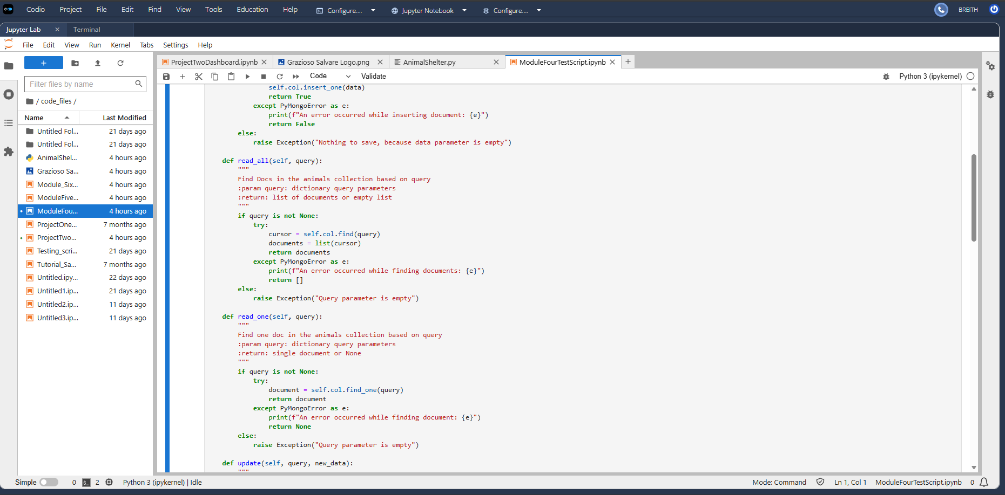
Code Example: -ProjectTwoDashboard.PY
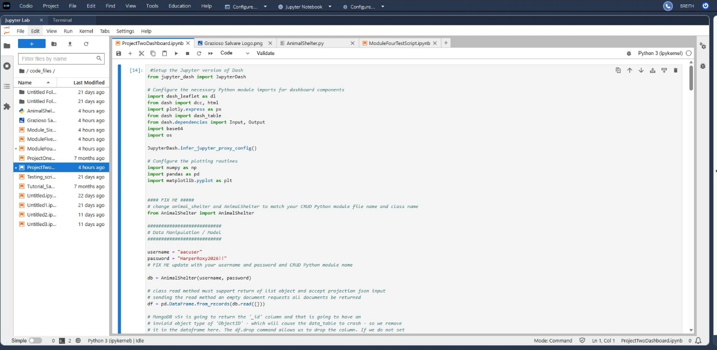

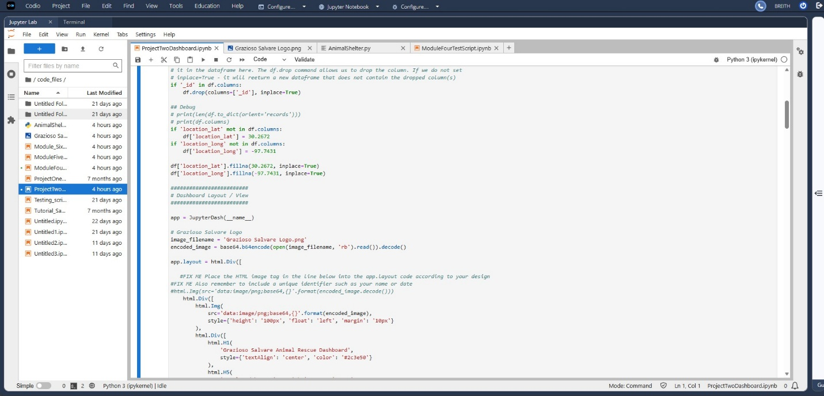

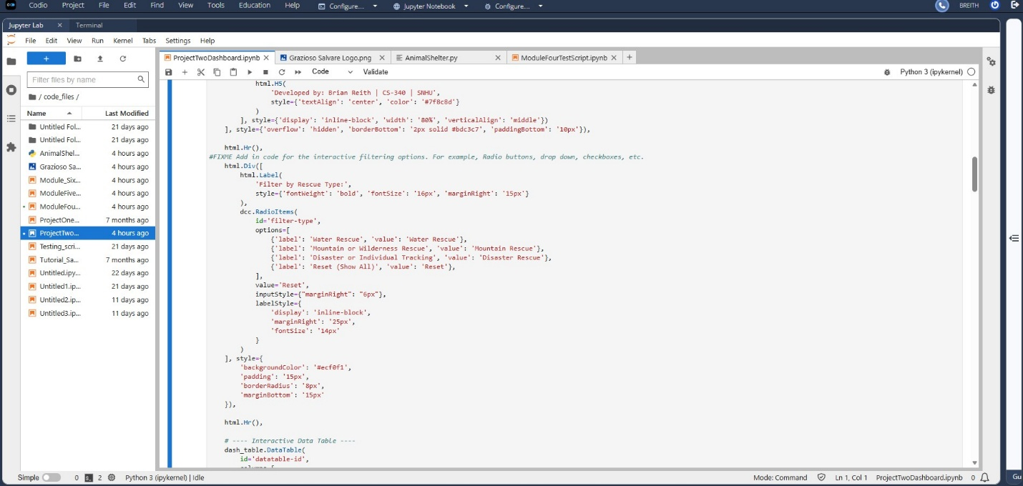

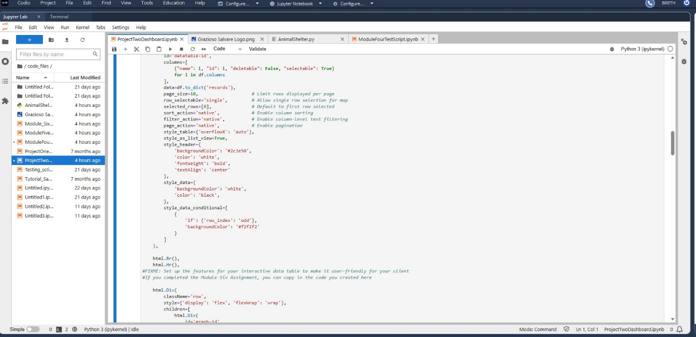

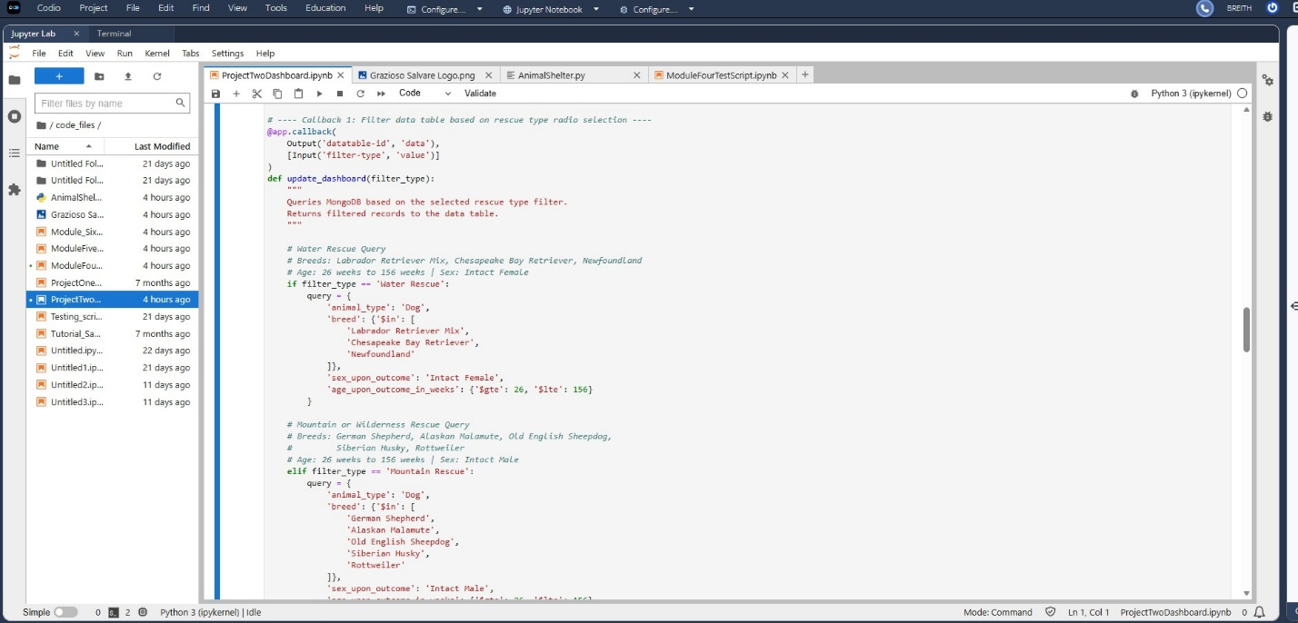

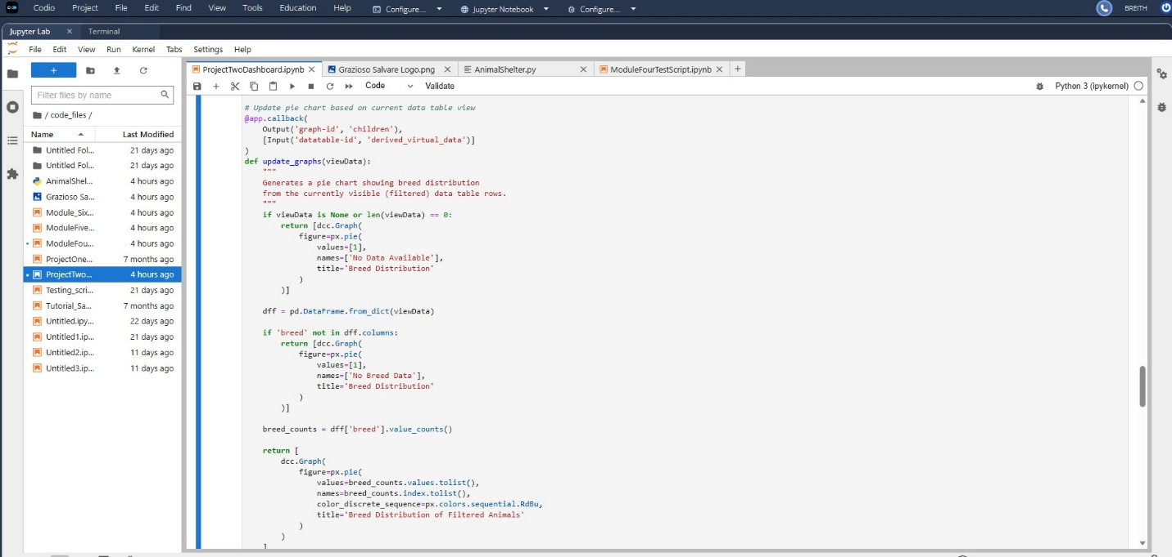

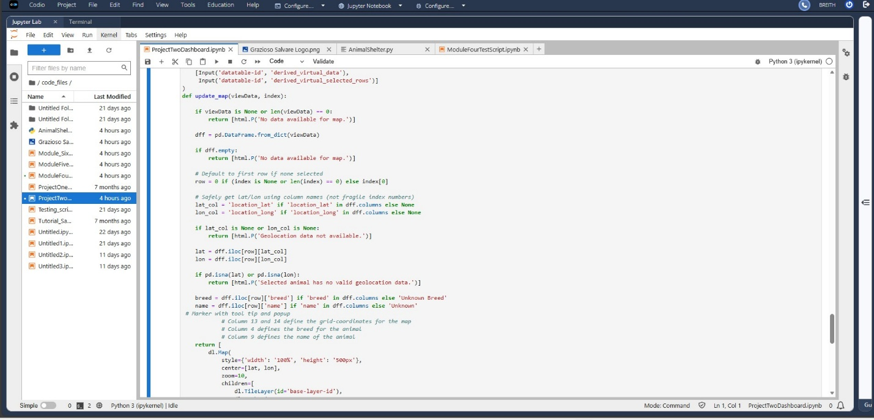

- TESTS
- Dashboard Startup:
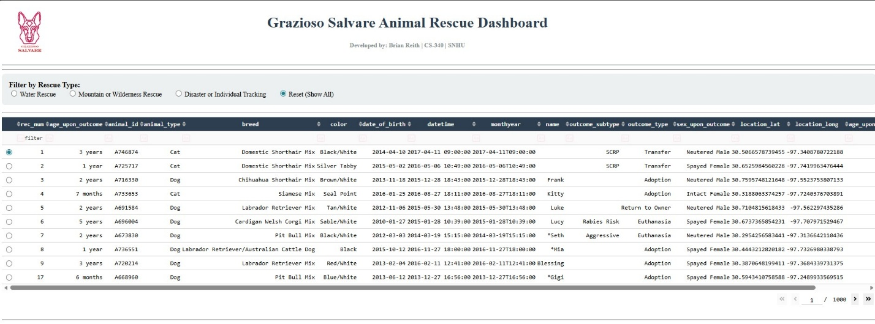

Water rescue filter
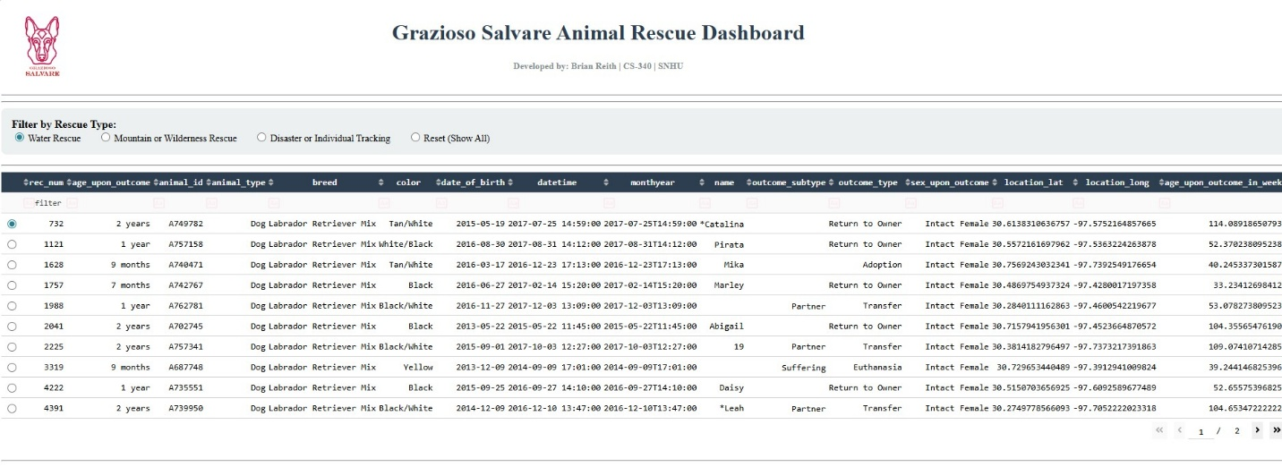

Wilderness / Mountain rescue filter
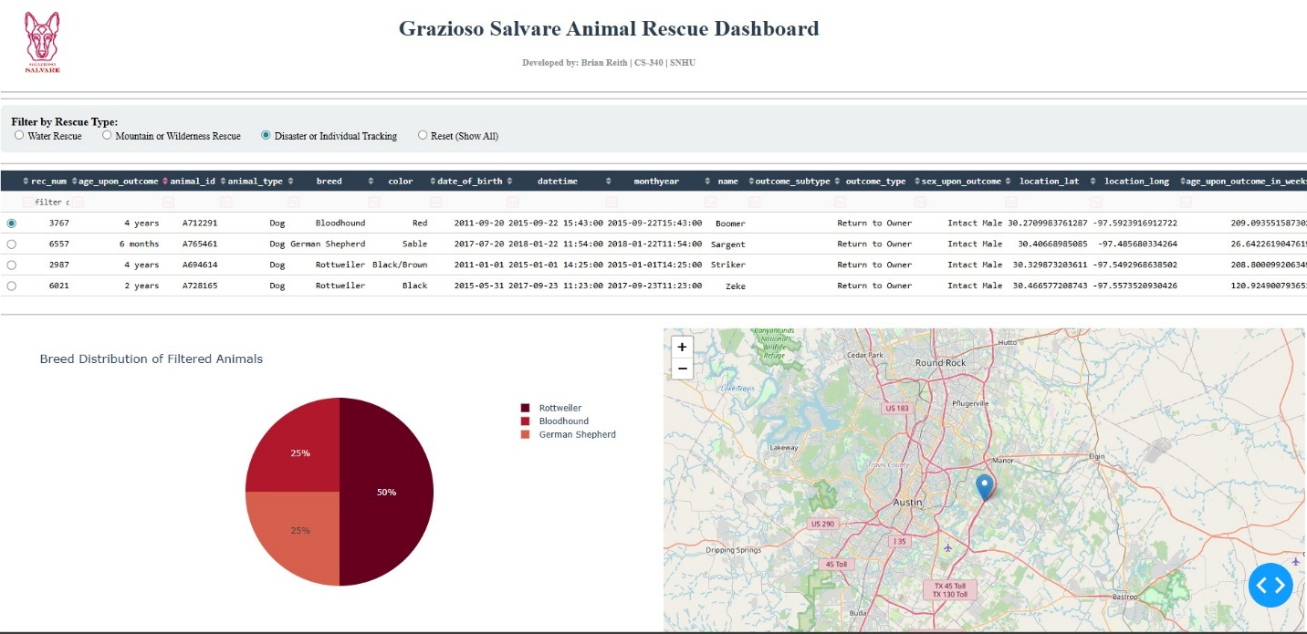

Disaster/Wilderness rescue filter


Map/ Pie Chart
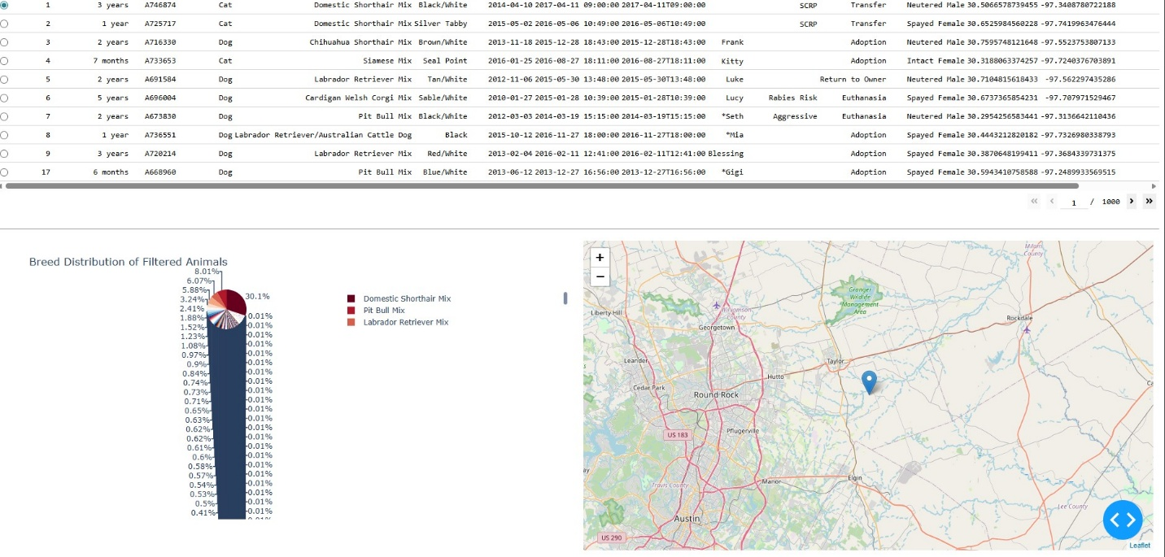

Challenge:
I faced some issues with this project. I corrected my animal shelter read method since MongoDB's {} command caused the dashboard loading problem. I also ensured the Grazioso Salvare logo was included so it would display properly.

